**Test Strategy**

>Facebook Group<

**Document Control**

**Document Detail**

|  |  |
| --- | --- |
| Title: | Test strategy to test Facebook Groups |
| Version: | 1.0 |
| Date: | 20th May 2019 |
| Electronic File Name: | TestStrategy.docx |
| Electronic File Location: | NA |
| Author: | Anomitro Munshi |
| Contributors: | NA |

**Change Control**

|  |  |  |  |
| --- | --- | --- | --- |
| Issue Date | Version | Details | Author |
| 20th May 2019 | v0.1d | Working Draft, ready for review | Anomitro |
|  |  |  |  |
|  |  |  |  |
|  |  |  |  |





**Table of Contents**

**1. TEST STRATEGY IDENTIFIE****R** **3**

**2. INTRODUCTIO****N** **3**

**3. TEST ITEM****S** **3**

**4. FEATURES TO BE TESTE****D** **3**

**5. FEATURES NOT TO BE TESTE****D** **3**

**6. APPROAC****H** **4**

**7. ‘PASS/FAIL’ CRITERI****A** **6**

**8. SUSPENSION CRITERIA & RESUMPTION REQUIREMENT****S** **7**

**9. TEST DELIVERABLE****S** **7**

**10. TESTING TASK****S** **7**

**11. ENVIRONMENTAL AND INFRASTRUCTURE NEED****S** **8**

**12. RESPONSIBILITY MATRI****X** **8**

**13. STAFFING AND TRAINING NEED****S** **8**

**14. SCHEDULES AND RESOURCE PLAN****S** **9**

**15. RISKS AND CONTINGENCIE****S** **9**

**16. APPROVAL****S** **9**

**1. Test Strategy Identifier**

The unique identifier for this Test Strategy is: CallHub123

**2. Introduction**

Groups provide a space to communicate about shared interests with certain people. You can create a group for anything — your family reunion, your after-work sports team, your book club — and [customize the group's privacy settings](https://www.facebook.com/help/220336891328465?helpref=about_content) depending on who you want to be able to join and see the group.

1. **Purpose**

The purpose of this Test Strategy is to define the overall approach that will be taken by the Test Team when delivering testing services to all of the projects within the business.

The document helps to clarify the testing activities, roles and responsibilities, processes and practice to be used across successive projects.

**3. Test Items**

* Facebook Group

**4. Features to be tested**

|  |
| --- |
| **FEATURES** |
| Admin : Group creation |
| Admin : Basic functionality -CRUD operations on posts |
| Admin : Testing of group features |
| User : Basic functionality -CRUD operations on posts |
| User : Testing of group features |
| Others |

**5. Features not to be tested**

|  |
| --- |
| **Features** |
| Accessibility of Facebook group in slow internet connection. |
| Accessibility of Facebook group simultaneously from two devices. |
| Security Aspects |

**6. Approach**

All testing tasks will be conducted in line with the Software Test Life Cycle (STLC) and in support of the Software Development Life Cycle (SDLC). The documents used within the SDLC will be completed both by the Test Team and the project participants that are responsible for providing information and deliverables to the Test Team.

It should be decided at the start of the project if there will be a Post Implementation Review after project delivery and this should be conducted within two weeks of project completion.

1. **Analysis & Planning Phase Entry Criteria**

For the project following criteria need to be met before the Test Items are accepted into the Analysis & Planning Phase:

* Release scope item list is locked and prioritised
* Documentation defining the scope items are approved and at release status
* All documents are under change control processes

1. **Analysis & Planning Phase Exit Criteria**

For the Analysis & Planning phase to be completed and allow items to move into the Test Phase the following criteria need to be achieved:

* Test Breakdowns and Test Cases are written and peer reviewed
* Knowledge Share document has been completed and reviewed by the Test Engineers
* Walkthrough and sign-off completed for the Test Plan and Test Breakdowns
* Defined Test Estimate has been published and agreed
* The list of features in the Test Breakdown have been prioritized.

1. **Test Phase Entry Criteria**

Before Test Items are made available for the Test Team to test it’s expected that:

* The *Test Cases* writing will be completed
* All test tools are available and test infrastructure are available for use during testing
* All Test Items are development complete
* The correct versions of the code have been deployed to the correct test environments
* Sanity and Unit tests have been completed successfully to demonstrate readiness for test

1. **Test Phase Exit Criteria**

For the Test Items to exit testing the following conditions will have to be met:

* The *Test Summary Report* will be completed.
* All planned testing activities has been completed to agreed levels.
* All high priority bugs have been fixed, retested and passed.
* No defects must be left in an open unresolved status.
  1. **Notification / Escalation Procedures**

The following diagram shows the notification and escalation paths to be followed for the duration of the project Test Phase.

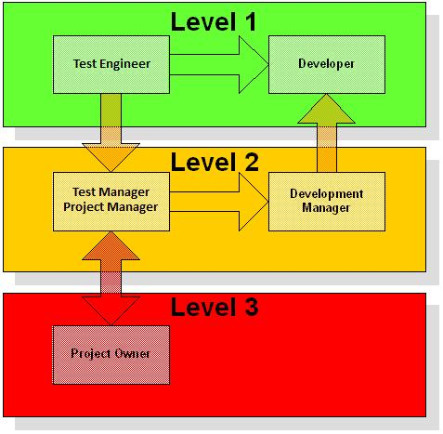

* 1. **Measures and Metrics**

At the Initiation Phase of the project the Test Team will publish a set of measures and metrics related to the test activities of their Planning & Analysis and Execution phases. The Test Plan also defines the milestone dates for key deliverables such as the Test Plan and these are metrics captured for ongoing statistical process analysis across successive projects.

**Test Preparation**

* Number of Test Scenarios vs. Number of Test Cases
* Number of Test Cases Planned vs. Ready for Execution
* Total time spent on Preparation vs. Planned time
* Total time spent on **automating** the test cases.

**Test Execution and Progress**

* Number of Tests Cases Executed vs. Test Cases Planned
* Number of Test Cases Passed, Failed and Blocked
* Total Time Spent on Execution vs Planned Time
* Total Regression Test Time.

**Bug Analysis**

* + Total Number of Bugs Raised and Closed per Test Run
  + Total Number of Bugs Closed v. Total Number of Bugs Re-Opened
  + Bug Distribution Totals by Severity per Test Run
  + Bug Distribution Totals by Test Item by Severity per Test Run

1. **‘Pass/Fail’ Criteria**

Test Items will be assigned a Pass or Fail state dependent on two criteria:

* Total number and severity of Bugs in an Open & Unresolved state in Tracker.
* The level of successfully executed test requirements.

**Table of Issue Severity**

|  |  |  |
| --- | --- | --- |
| Severity | Definition | Maximum |
|  |  | Allowable |
| S1 | Crash/Legal – System crash, data loss, no workaround, legal, Ship Killer | 0 |
|  |  |  |
| S2 | Major – Operational error, wrong result | <Set by PM> |
|  |  |  |
| S3 | Minor – Minor problems | <Set by PM> |
|  |  |  |
| S4 | Incidental – Cosmetic problems | <Set by PM> |
|  |  |  |
| S5 | N/A – Not Applicable; used for feature requests and Development Tasks | Reference Only |
|  |  |  |

**Table of Test Scenario Priority**



|  |  |  |  |
| --- | --- | --- | --- |
| Test Scenario | | Definition | Minimum Pass Rate |
| P1 | – Critical | Essential to the Product | 100% |
| P2 | – |  |  |
| Important |  | Necessary to the Product | <Set by PM> |
| P3 | – |  |  |
| Desirable |  | Preferred, but not essential to the Product | <Set by PM> |

**8. Suspension Criteria & Resumption Requirements**

Testing of Test Items will be suspended if:

**1a) Suspension criteria:**

A Severity 1 issue is logged and requires fixing before further testing can take place (a Blocking Issue)

**1b) Resumption requirement:**

The issue will need to be fixed before the Test Item is returned to the Test Team for testing.

**2a) Suspension criteria:**

Significant differences exist between observed behaviour of the Test Item and that shown in Test

Scenario, Test Case or as expected from the previous version of the technology.

**2b) Resumption requirement:**

Development, the Test Team and PM must come to a conclusion on resolving the issue and agreeing a definition of the expected behaviour.

**3a) Suspension criteria:**

A Test Item sent for testing fails more than 20% of Developer Unit Tests.

**3b) Resumption requirement:**

The Test Item must be fixed or Unit Tests refactored if out of date and then demonstrated to pass with <20% failure rate.

**9. Test Deliverables**

The following artefacts will be produced during the testing phase:

* Test Plan (this document itself)
* Test Cases
* Test Scripts
* Defect/Enhancement Logs
* Test Reports
* Bug Reporting
* Test Summary Reports

**10. Testing Tasks**

The Testing Tasks that the Test Team will deliver cover the following scope:

* **Fully In Scope:** Functional and Automated Regression Testing
* **Partially in Scope:** Cross Browser Compatibility, all forms of Non-Functional.
* **Out of Scope:** Performance testing,Accessibility Compliance Testing, Security Testing, User Documentation Review.

**11. Environmental and Infrastructure Needs**

The following detail the environmental and infrastructure needs required for the testing of Facebook group Test Items and execution of Regression Testing.

**Hardware.**

* Necessary configured machines.

**Software**

* Selenium
* TestNG
* RestAssured
* Postman
* JIRA

**Infrastructure**

* Network connections are available on all Test Systems as required.

**Test Repository**

* [https://github.com](https://github.com/)

**12. Responsibility Matrix**

The table below outlines the main responsibilities in brief for test activities:

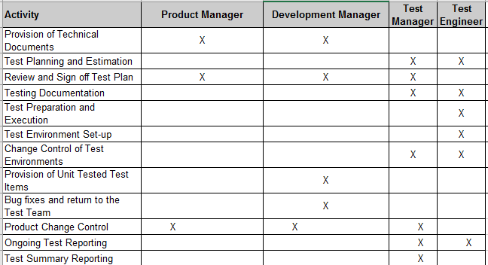

**13. Staffing and Training Needs**

**Staffing.**

Staffing levels for the test activities will be:

* 1 x Test Manager for the duration of test planning at 50% effort against plan.
* The required number of Test Engineers for the duration of test execution at 100% effort against plan.

**Training.**

For each project the training needs will be assessed and defined in the Test Plan.

**14. Schedules and Resource Plans**

**NA**

**15. Risks and Contingencies**

|  |  |  |  |  |
| --- | --- | --- | --- | --- |
|  | **Risk** | **Mitigation Strategy** | **Impact** |  |
|  |  |  |  |  |
|  | Delays in delivering completed Test Items | Product Management and Development to |  |  |
|  | advise of any delays and adjust Release |  |  |
| 1 | from Development would impact test | High |  |
| Scope of Resources to allow the test activities |  |
|  | timescales and final Release quality |  |  |
|  | to be performed. |  |  |
|  |  |  |  |
|  |  |  |  |  |
|  | Delays in the turn around time for fixing | Strong management of bug resolution would |  |  |
| 2 | critical bugs, which would require re- | be required from Development to ensure bugs |  |  |
| testing, could have an impact on the | are fixed and available for re-testing in the | High |  |
|  |  |
|  | project dates. | scheduled time. |  |  |
|  |  |  |  |  |
|  | The Test Team, Development or PM | The Test Team, Development and PM teams |  |  |
|  | teams require domain guidance from one |  |  |
| 3 | to ensure they are available at critical points | Medium |  |
| or the other and they are not available. |  |
|  | or contactable during the project activities. |  |  |
|  | This would delay project activities. |  |  |
|  |  |  |  |
|  |  |  |  |  |
|  |  | The Test Team will record untested features | Low |  |
| 4 | Features of Test Items will not be testable. | and request the PM to assess business risk in |  |
|  |  |
|  |  | support of the release of untested features. |  |  |
|  |  |  |  |  |
|  | Unexpected dependencies between Test | Information about dependencies is updated |  |  |
|  | Items and service components are |  |  |
| 5 | and communicated promptly to allow timely | Low |  |
| encountered that require revision of Test |  |
|  | revision of Test Scenarios and Test Cases |  |  |
|  | Scenarios and related Test Cases. |  |  |
|  |  |  |  |
|  |  |  |  |

**16. Approvals**

The following people are required to approve the Test Strategy

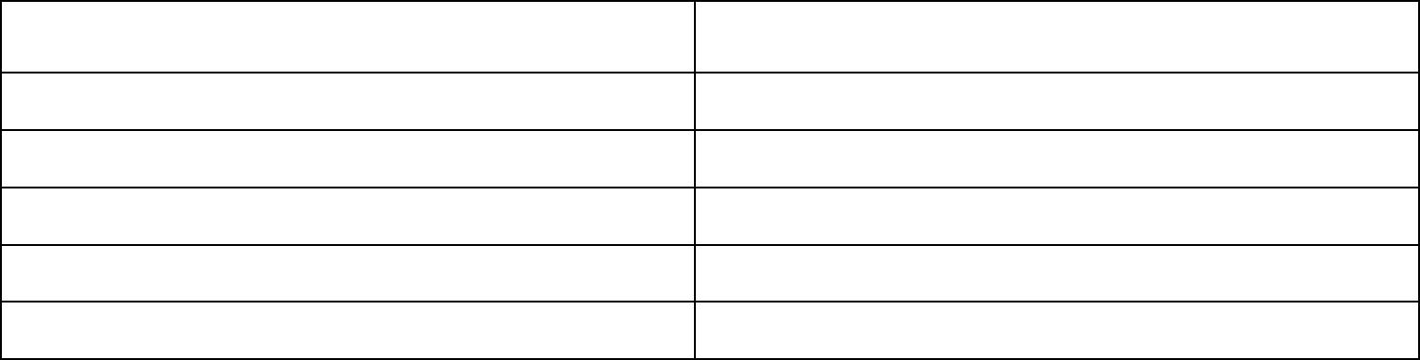

|  |  |
| --- | --- |
| **Approval By** | **Approval** |
|  |  |

Test Manager

The Test Department Manager

Product Owner

Development Manager

Project Manager

